WVS variables that fit SDT

Perplexity suggestion:
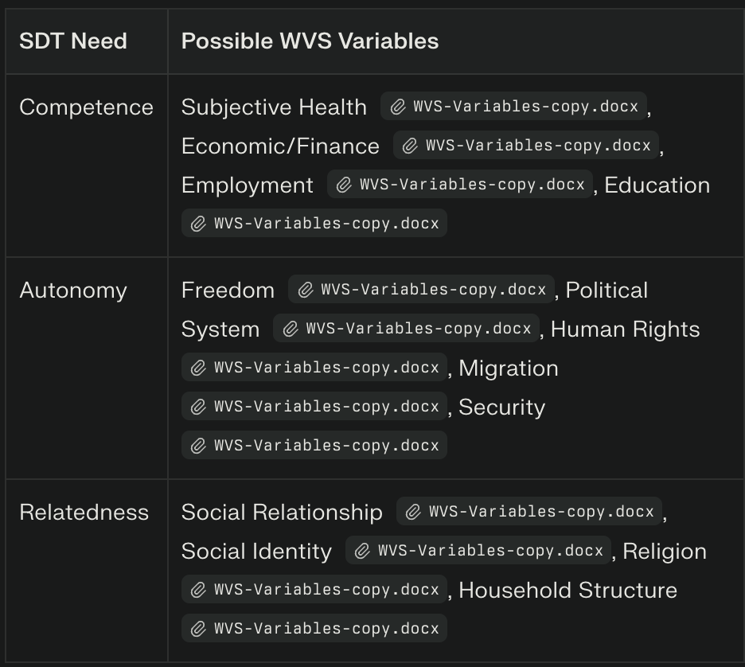

Competence (12 variables):
Q47 - Subjective Health (Reverse)
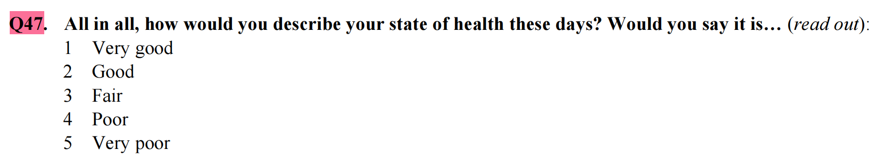
Q50 - Financial Situation
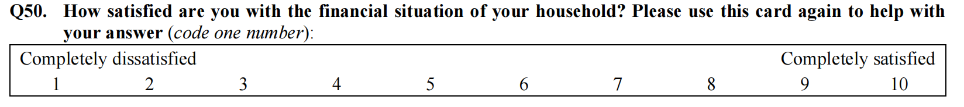
Q56 - Financial Situation compare to parents (Unordered categorical)
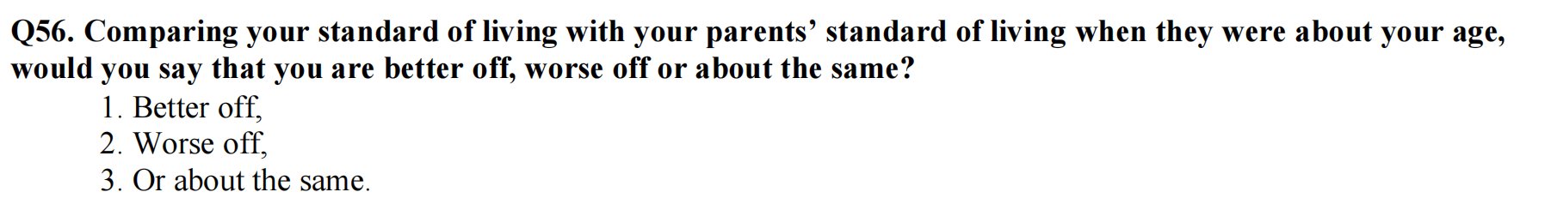
Q286 - Family financial situation (Reverse)
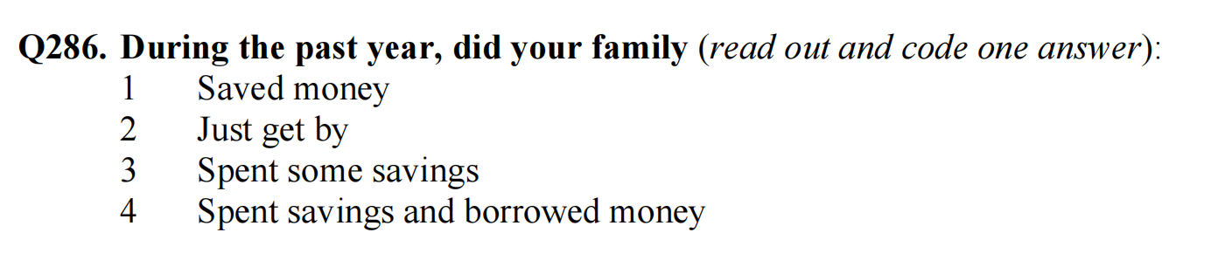

Q142 - Risk of unemployment

Q279 (Only Q279!) - Type of employment (Unordered categorical)
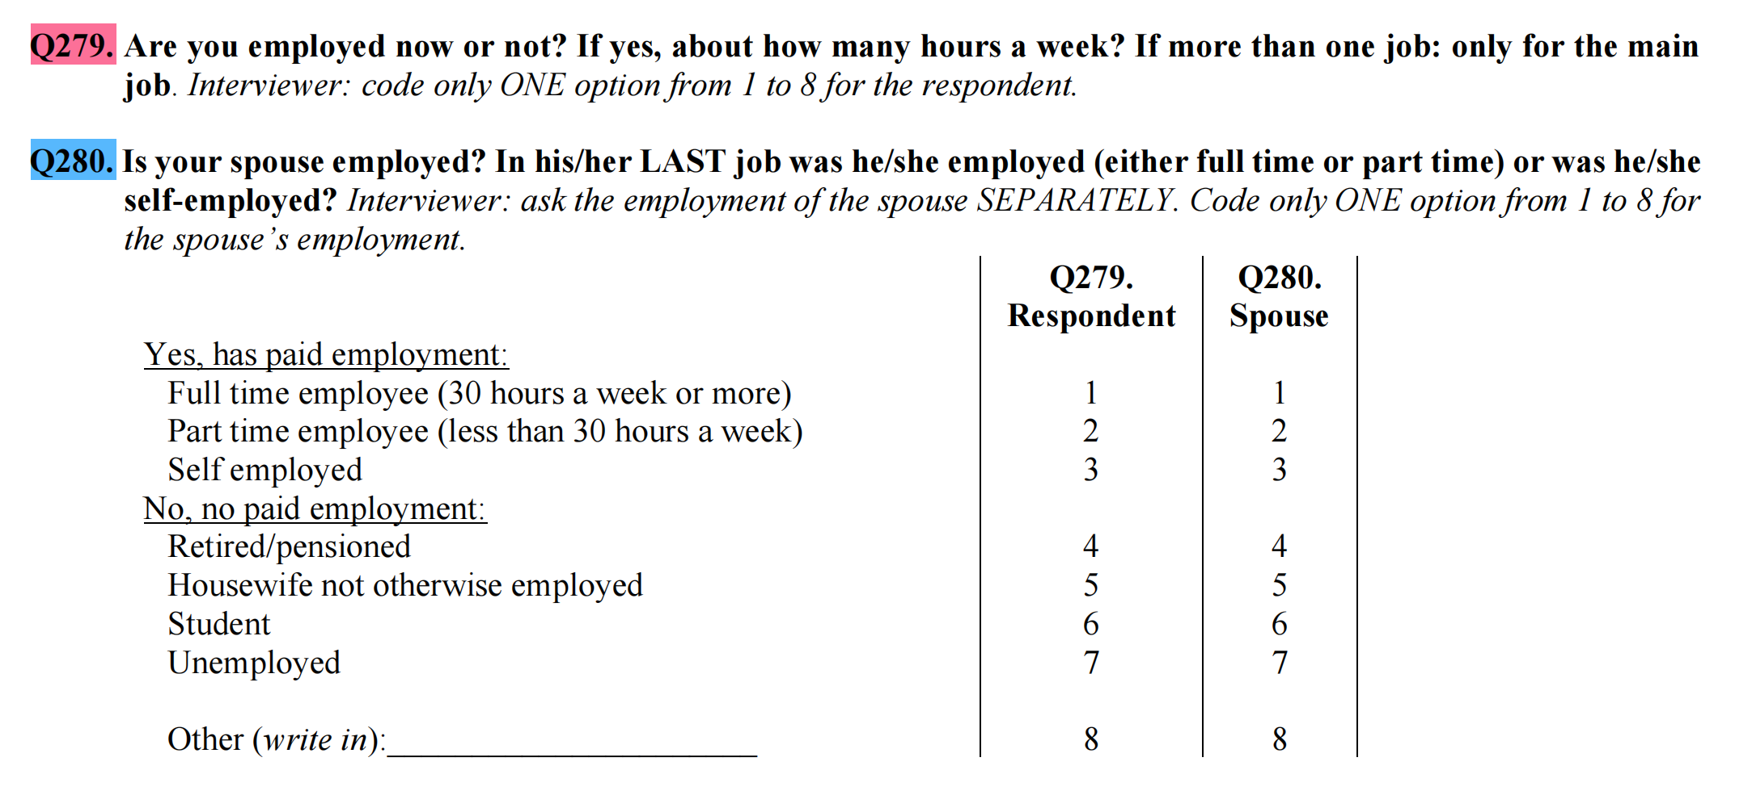
Q281 (Only Q281!) - Type of employment (Unordered categorical)
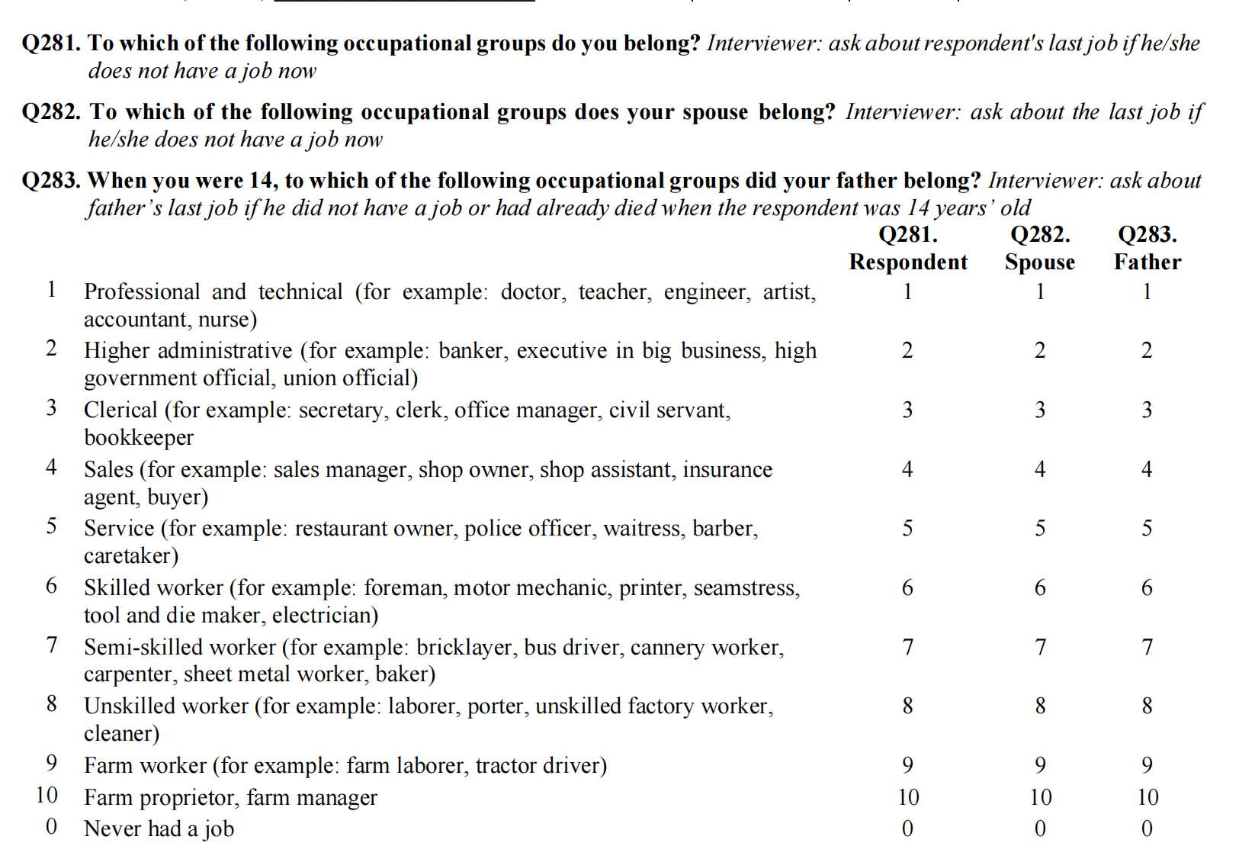

Q275 (Only Q275!) - Education level
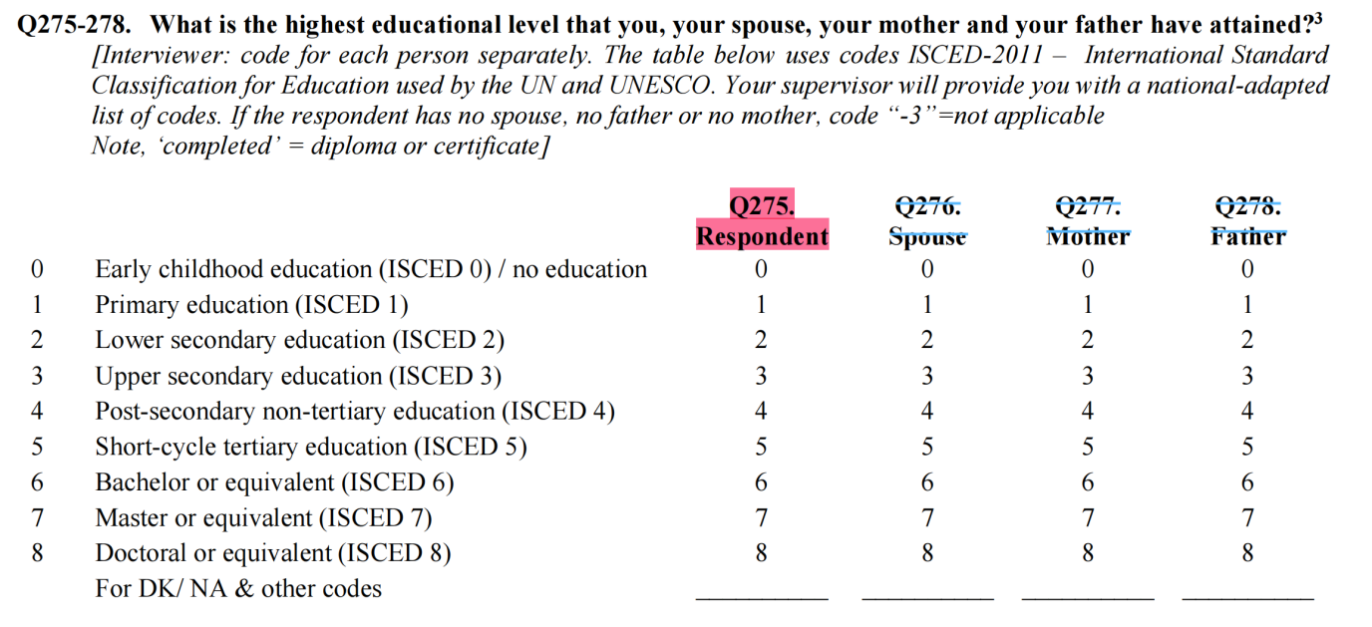

Q143 - Education that could give to next generation (Reverse)

Q287 - Social status (Reverse)
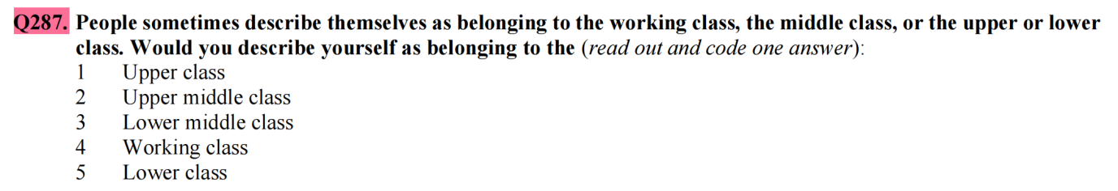

Q285 - Status in the family (Could transform to dummy: No - 0; Yes - 1)
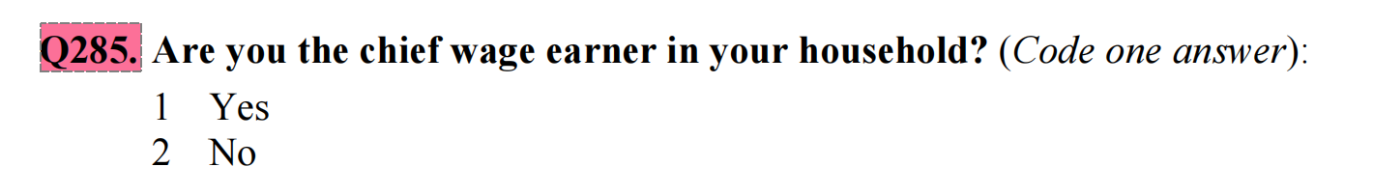
Q288 - Household social status
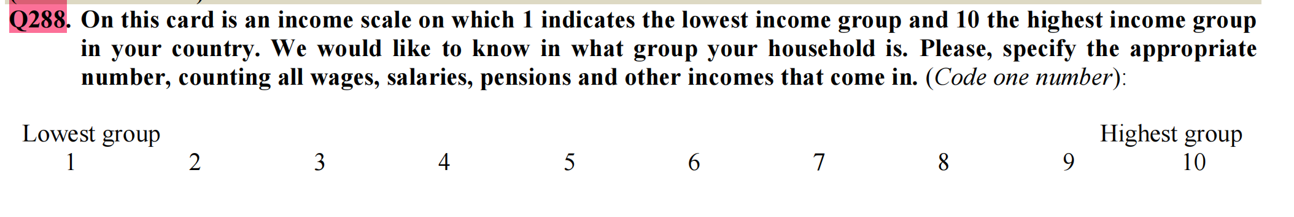

Q112 - Corruption (Reverse)
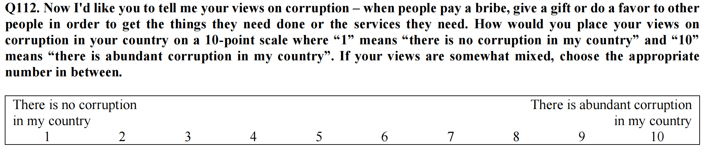
Autonomy (7 variables):
Q48 - Free to choose in life
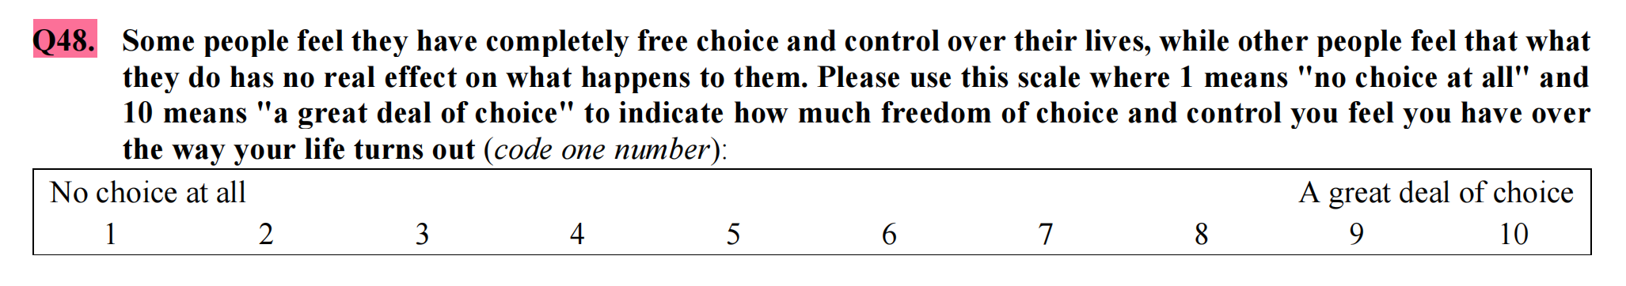
Q146, Q147, Q148 - Worry about public security crisis
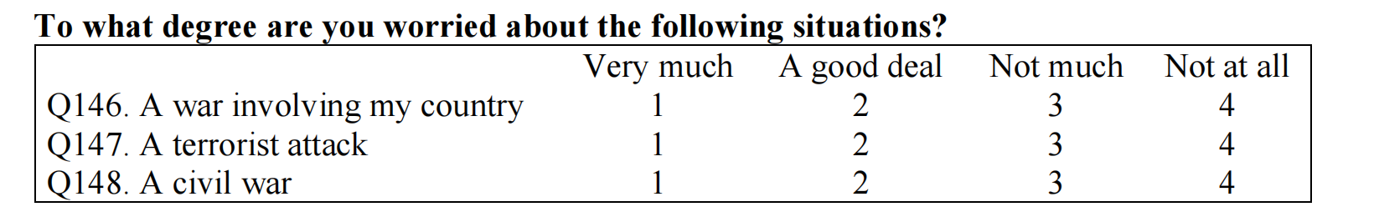
Q251 - Democracy
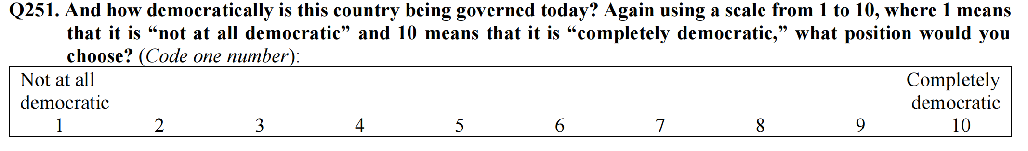
Q253 - Human Right (Reverse)
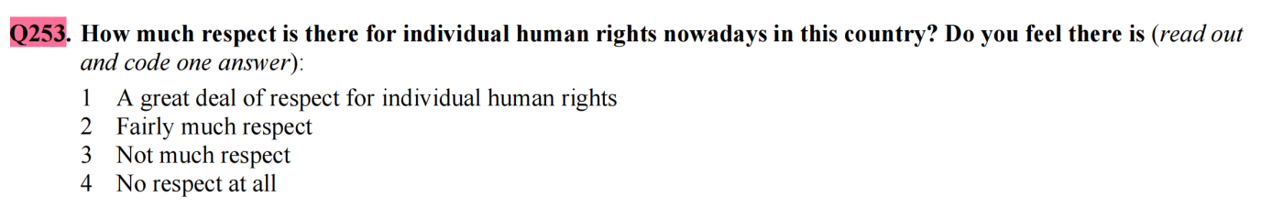
Q131 - Security (Reverse)
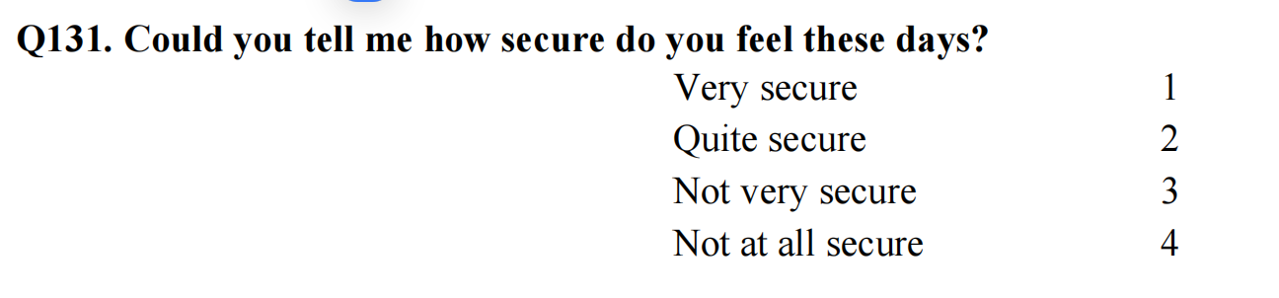

Relatedness (31 variables):
Q57 - Overall trust to others (Could code to Need to be very careful = 0, Most people can be trusted = 1)
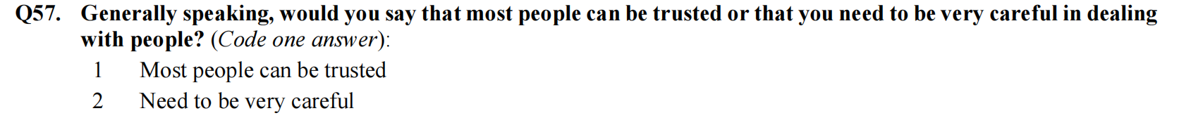
Q58 to Q63 - Subset of trust to others (Reverse)
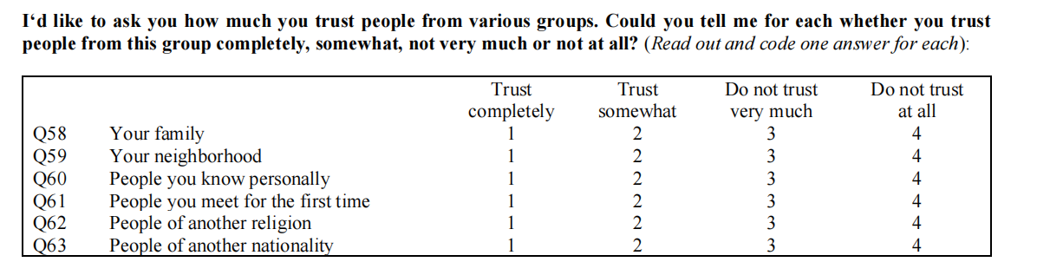

Q254 - Social Identity (Reverse)
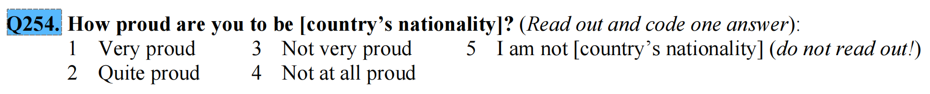

Q255 to Q259 - Trust to bigger world
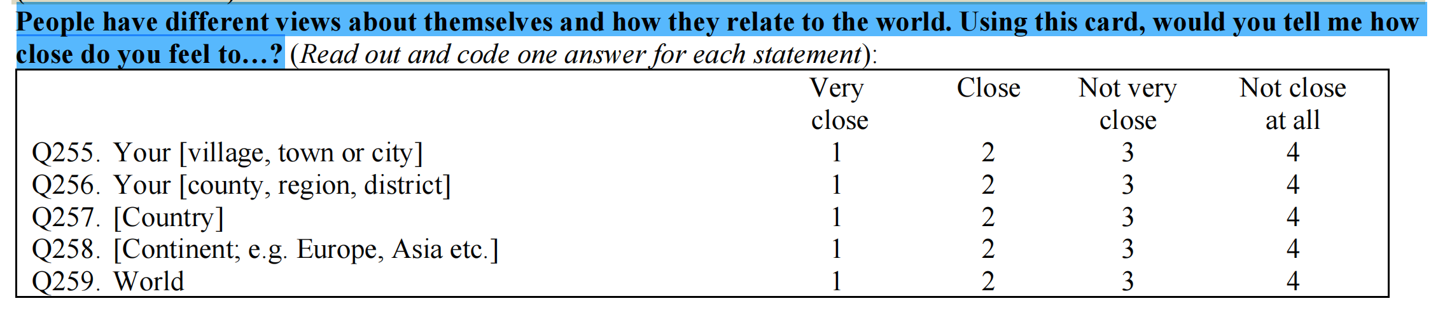

Q164 - Religion
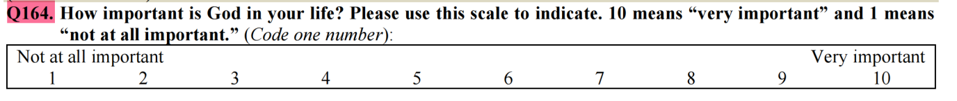
Q171 - Attend to religious services (Reverse)
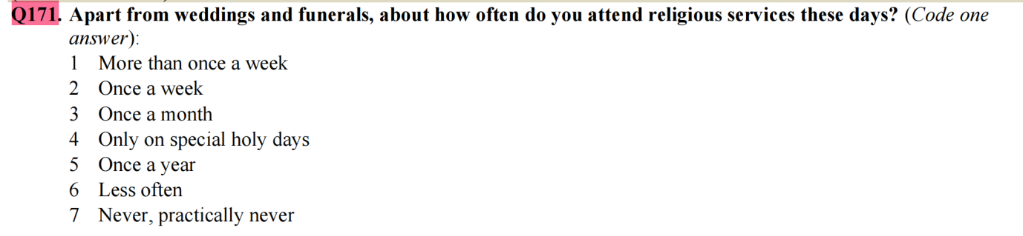
Q172 - Pray (Reverse)
Q94 to Q105 - Attending activities
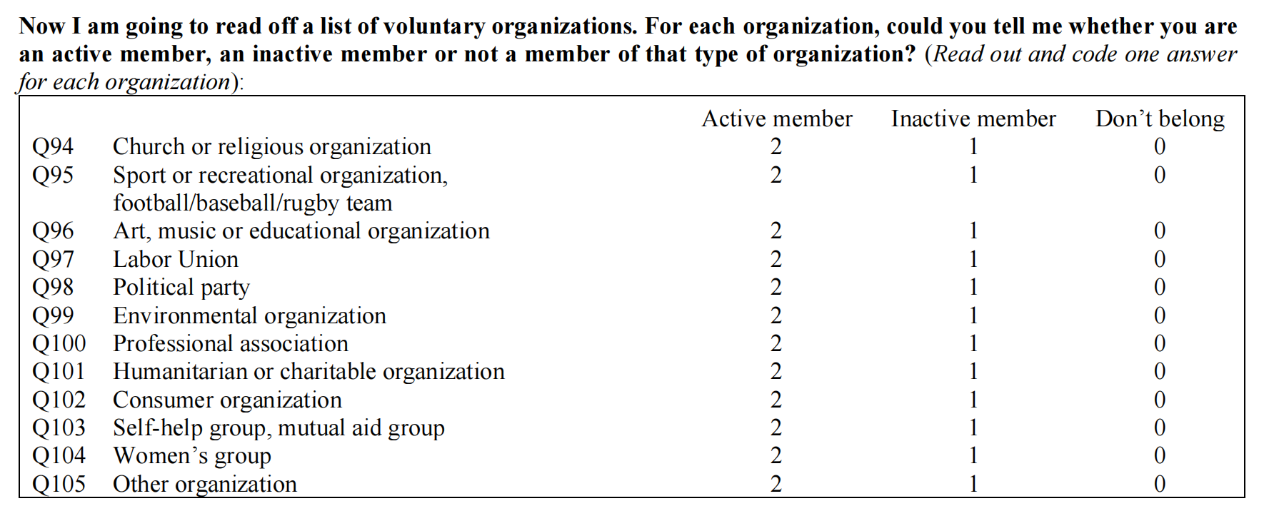
Q269 - Citizenship
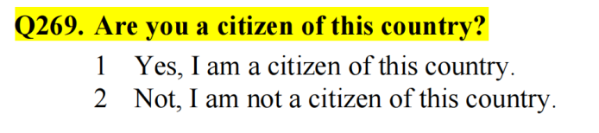
Q270 - Family member numbers
Q274 - Children number

